 |  | 1 | Task 1: Implementing a Stack (LIFO)  - Task: Use AI to help implement a Stack class in Python with the following operations: push(), pop(), peek(), and is_empty().  - Instructions:  - Ask AI to generate code skeleton with docstrings.  - Test stack operations using sample data.  - Request AI to suggest optimizations or alternative implementations (e.g., using collections.deque).  - Expected Output:  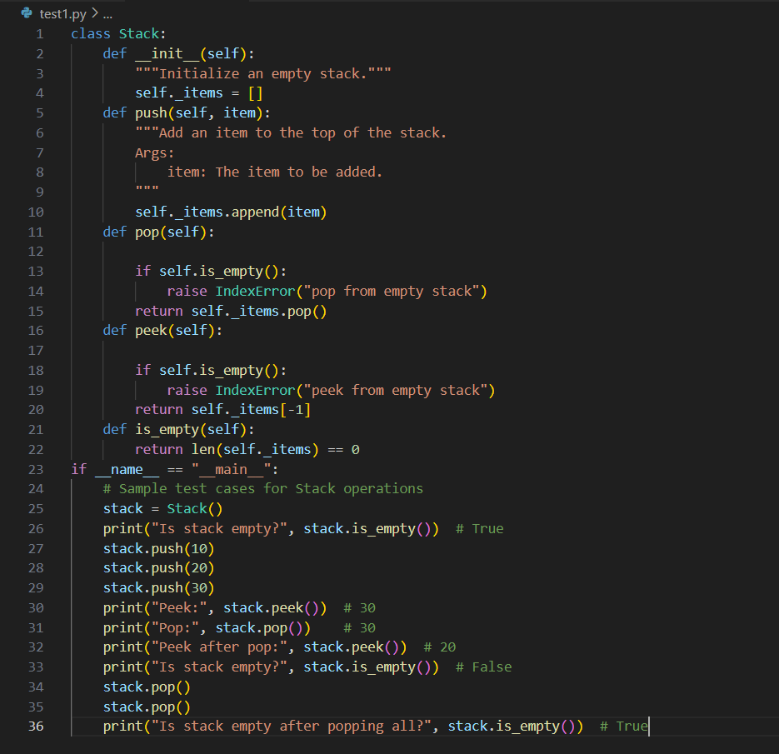  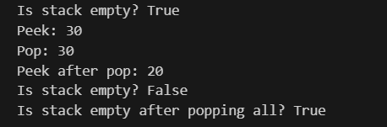  A working Stack class with proper methods, Google-style docstrings, and inline comments for tricky parts.  Task 2: Queue Implementation with Performance Review  - Task: Implement a Queue with enqueue(), dequeue(), and is_empty() methods.  - Instructions:  - First, implement using Python lists.  - Then, ask AI to review performance and suggest a more efficient implementation (using collections.deque).  - Expected Output:  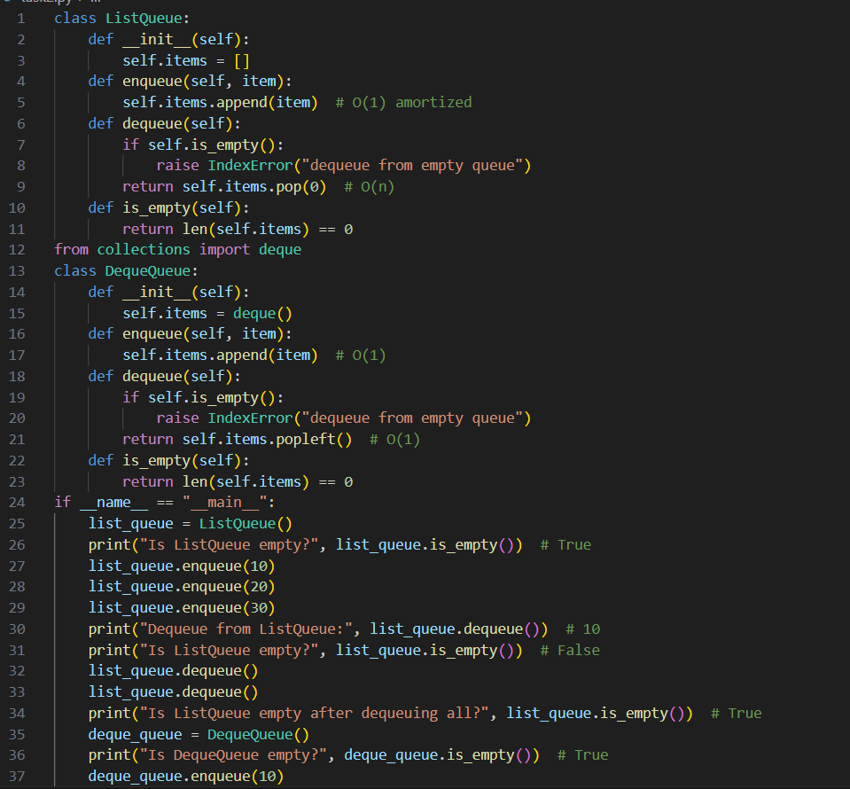  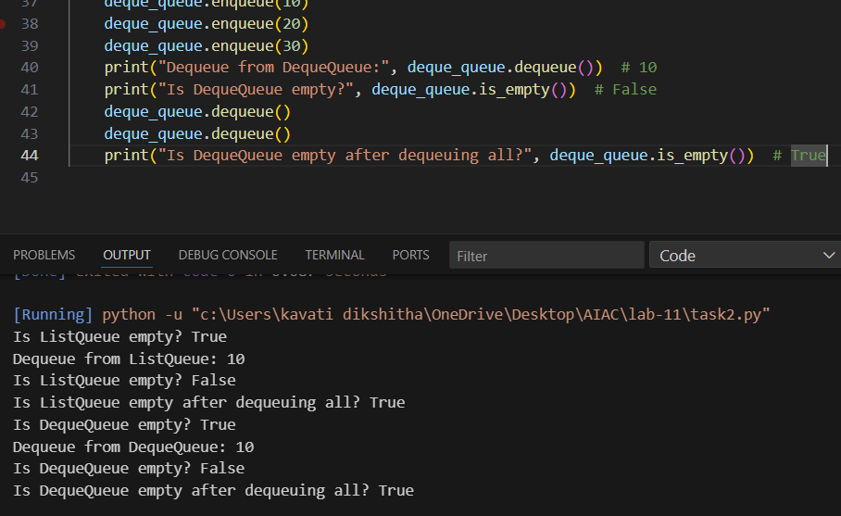  Two versions of a queue: one with lists and one optimized with deque, plus an AI-generated performance comparison.  Task 3: Singly Linked List with Traversal  - Task: Implement a Singly Linked List with operations: insert_at_end(), delete_value(), and traverse().  - Instructions:  - Start with a simple class-based implementation (Node, LinkedList).  - Use AI to generate inline comments explaining pointer updates (which are non-trivial).  - Ask AI to suggest test cases to validate all operations.  - Expected Output:  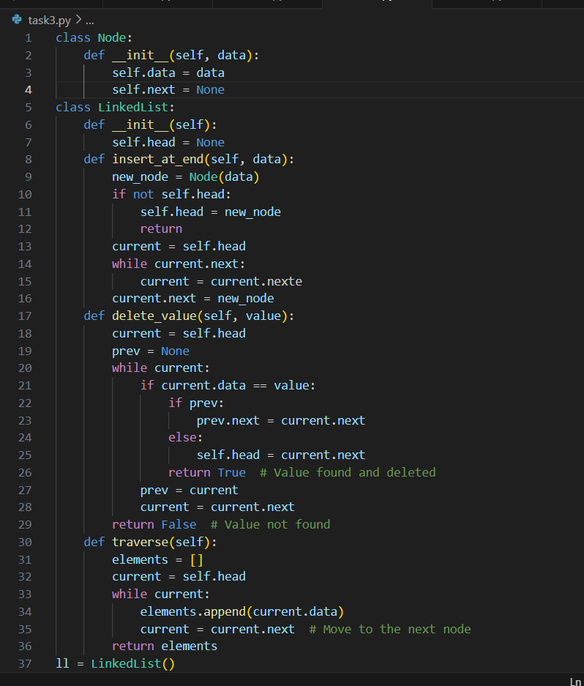  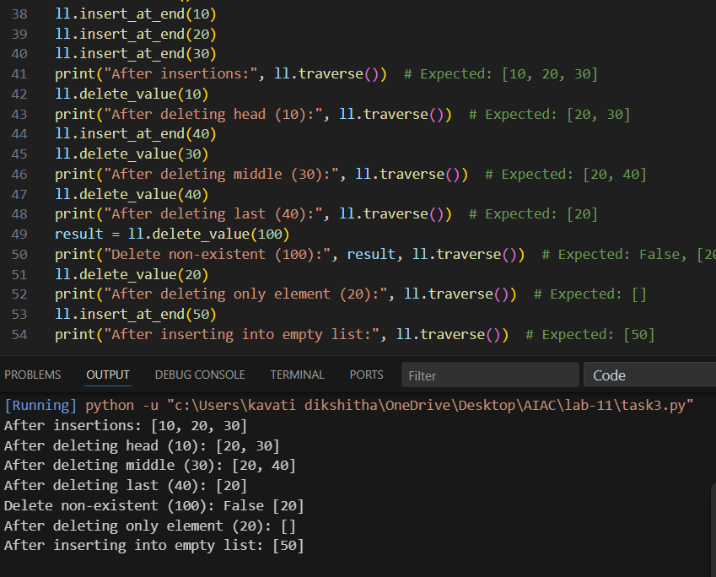  - A functional linked list implementation with clear comments explaining the logic of insertions and deletions.  Task 4: Binary Search Tree (BST)  - Task: Implement a Binary Search Tree with methods for insert(), search(), and inorder_traversal().  - Instructions:  - Provide AI with a partially written Node and BST class.  - Ask AI to complete missing methods and add docstrings.  - Test with a list of integers and compare outputs of search() for present vs absent elements.  - Expected Output:  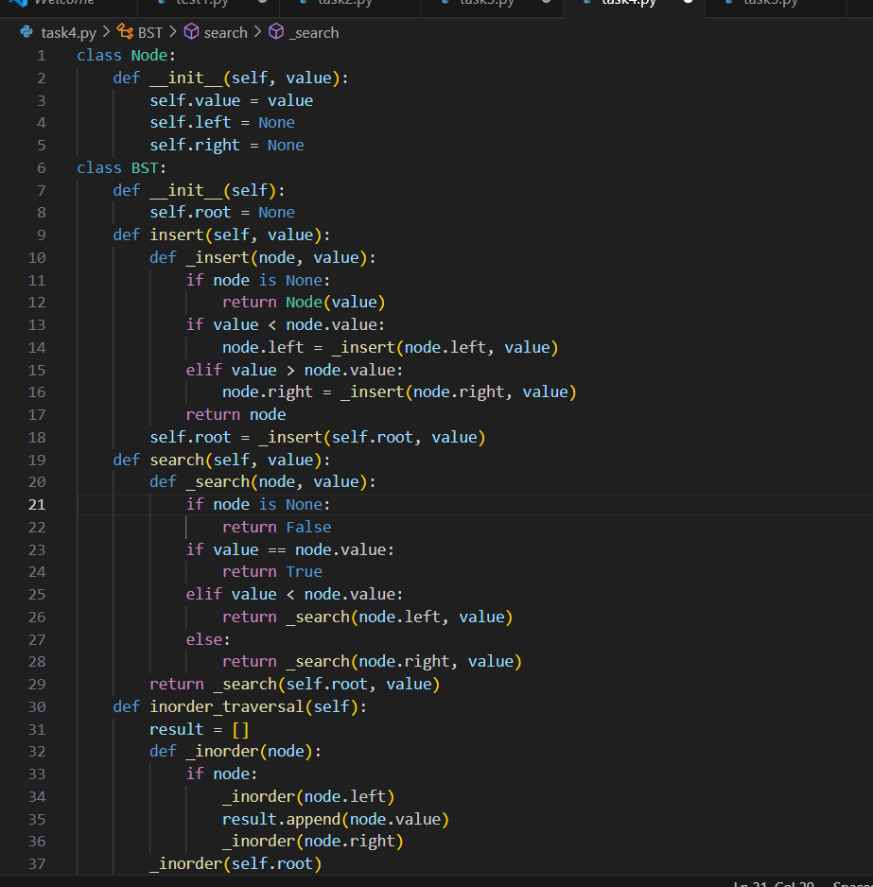  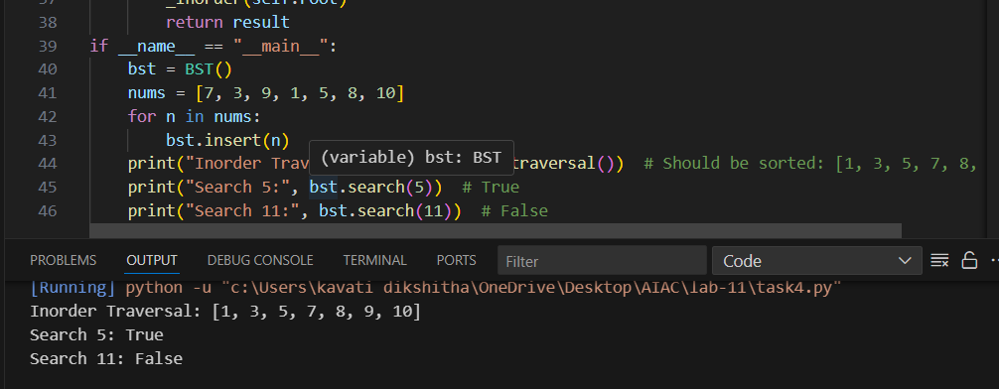  - A BST class with clean implementation, meaningful docstrings, and correct traversal output.  Task 5: Graph Representation and BFS/DFS Traversal  - Task: Implement a Graph using an adjacency list, with traversal methods BFS() and DFS().  - Instructions:  - Start with an adjacency list dictionary.  - Ask AI to generate BFS and DFS implementations with inline comments.  - Compare recursive vs iterative DFS if suggested by AI.  - Expected Output:  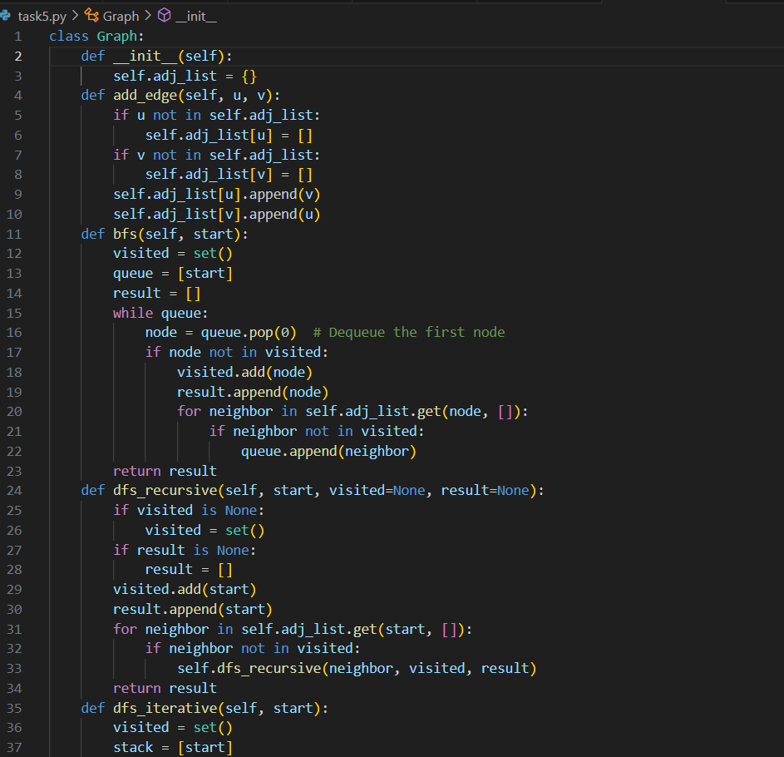  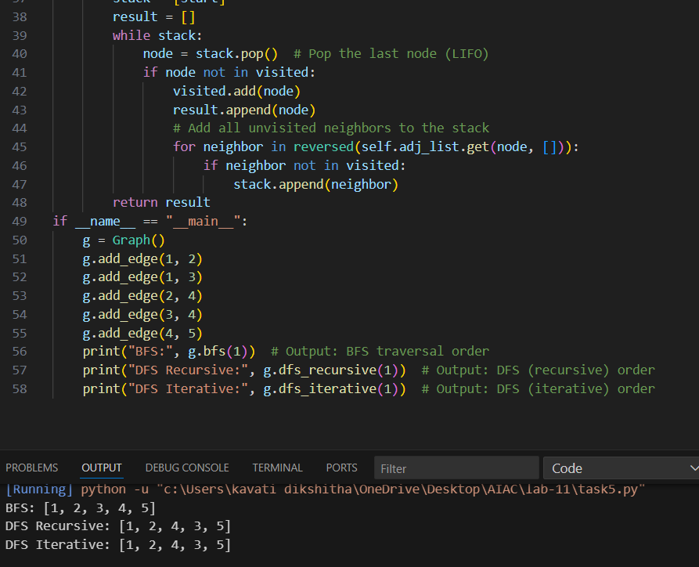  - A graph implementation with BFS and DFS traversal methods, with AI-generated comments explaining traversal steps. | Week6 - Thursday

